WIRELESS COMMUNICATION ETEC 463

**Faculty Name:** Mr. Saurabh Rastogi **Student Name:** Syeda Reeha Quasar

**Roll No:** 14114802719

**Batch:** 7C7



Maharaja Agrasen Institute of Technology, PSP Area, Sector 22, Rohini, Delhi – 110085

**INDEX**

|  |  |  |  |  |  |
| --- | --- | --- | --- | --- | --- |
| Exp. No. | Experiment Name | Date of Performance | Date of Checking | Marks | Signature |
| 1. | Introduction to Scilab. |  |  |  |  |
| 2. | Write a program in Scilab to Calculate Frequency Reuse Distance ,Co-Channel Interference reduction factor, Cellular System Capacity, S/I Ratio for a given variables. |  |  |  |  |
| 3. | Write a program in Scilab to Calculate maximum traffic intensity and maximum number of users accomodated in Erlang B and Erlang C system for given no of channels. |  |  |  |  |
| 4. | Write a Program in Scilab to calculate Bit Error rate performance of BPSK modulated signal over only AWGN channel and AWGN and Rayleigh channel both. |  |  |  |  |
| 5. | Program in Scilab to Generate Walsh Codes and then spread the user information using it. |  |  |  |  |
| 6. | Write a program in scilab to Generate PN Sequence for CDMA Systems. |  |  |  |  |
| 7. | Write a Program in NS3 to connect WIFI TO BUS (CSMA) Network. |  |  |  |  |
| 8. | Write a Program in NS3 to create WIFI Network in SIMPLE INFRASTRUCTURE  MODE (of nodes) |  |  |  |  |
| 9. | Write a Program in NS3 to Create a wireless mobile ad-hoc network between three nodes. |  |  |  |  |

# Experiment – 1

## AIM –

Introduction to Scilab.

## Overview:

Scilab is a programming language associated with a rich collection of numerical algorithms covering many aspects of scientific computing problems. From the software point of view, Scilab is an interpreted language. This generally allows to get faster development processes, because the user directly accesses to a high-level language, with a rich set of features provided by the library. The Scilab language is meant to be extended so that user-defined data types can be defined with possibly overloaded operations.

Scilab users can develop their own module so that they can solve their particular problems. The Scilab language allows to dynamically compile and link other languages such as Fortran and C: this way, external libraries can be used as if they were a part of Scilab built-in features.

Scilab also interfaces LabVIEW, a platform and development environment for a visual programming language from National Instruments. From the license point of view, Scilab is a free software in the sense that the user does not pay for it and Scilab is an open source software, provided under the Cecill license. The software is distributed with source code, so that the user has an access to Scilab most internal aspects. Most of the time, the user downloads and installs, a binary version of Scilab since the Scilab consortium provides Windows, Linux and Mac OS executable versions. An online help is provided in many local languages. From a scientific point of view, Scilab comes with many features. At the very beginning of Scilab, features were focused on linear algebra. But, rapidly, the number of features extended to cover many areas of scientific computing. The following is a short list of its capabilities:

* Linear algebra, sparse matrices,
* Polynomials and rational functions,
* Interpolation, approximation,
* Linear, quadratic and non linear optimization,
* Ordinary Differential Equation solver and Differential Algebraic Equations solver,
* Classic and robust control, Linear Matrix Inequality optimization,
* Differentiable and non-differentiable optimization,
* Signal processing,
* Statistics.

Scilab provides many graphics features, including a set of plotting functions, which allow to create 2D and 3D plots as well as user interfaces. The Xcos environment provides an hybrid dynamic systems modeler and simulator.

## Installing Scilab under Mac OS:

Under Mac OS, the binary versions are available from Scilab website as a .dmg file. This binary works for Mac OS versions starting from version 10.5. It uses the Mac OS installer, which provides a classical installation process. Scilab is not available on Power PC systems. Scilab version 5.2 for Mac OS comes with a Tcl / Tk library which is disabled for technical reasons. As a consequence, there are some small limitations on the use of Scilab on this platform. For example, the Scilab / Tcl interface (TclSci), the graphic editor and the variable editor are not working. These features will be rewritten in Java in future versions of Scilab and these limitations will disappear. Still, using Scilab on Mac OS system is easy, and uses the shorcuts which are familiar to users of this platform. For example, the console and the editor use the Cmd key (Apple key) which is found on Mac keyboards. Moreover, there is no right-click on this platform. Instead, Scilab is sensitive to the Control-Click keyboard event. For now, Scilab comes on Mac OS with a linear algebra library which is optimized and guarantees portability. Under Mac OS, Scilab does not come with a binary version of ATLAS, so that linear algebra is a little slower for that platform.

## The Console:

The console The first way is to use Scilab interactively, by typing commands in the console, analyzing Scilab result, continuing this process until the final result is computed. This document is designed so that the Scilab examples which are printed here can be copied into the console. The goal is that the reader can experiment by himself Scilab behavior. This is indeed a good way of understanding the behavior of the program and, most of the time, it allows a quick and smooth way of performing the desired computation. In the following example, the function disp is used in interactive mode to print out the string ”Hello World !”.

-->s=" Hello World ! " s = Hello World !

--> disp ( s) Hello World !

In the previous session, we did not type the characters ”-->” which is the prompt, and which is managed by Scilab. We only type the statement s="Hello World!" with our keyboard and then hit the key. Scilab answer is s = and Hello World!. Then we type disp(s) and Scilab answer is Hello World!.

## Creating real variables:

Scilab is an interpreted language, which implies that there is no need to declare a variable before using it. Variables are created at the moment where they are first set. In the following example, we create and set the real variable x to 1 and perform a multiplication on this variable. In Scilab, the ”=” operator means that we want to set the variable on the left hand side to the value associated to the right hand side (it is not the comparison operator, which syntax is associated to the ”==” operator).

-->x =1 x = 1.

-->x = x * 2 x = 2.

The value of the variable is displayed each time a statement is executed. That behavior can be suppressed if the line ends with the semicolon ”;” character, as in the following example.

-->y =1;

-->y=y *2;

## Variable Name:

Variable names may be as long as the user wants, but only the first 24 characters are taken into account in Scilab. For consistency, we should consider only variable names which are not made of more than 24 characters. All ASCII letters from ”a” to ”z”, from ”A” to ”Z” and from ”0” to ”9” are allowed, with the additional letters ”%”, ” ”, ”#”, ”!”, ”$”, ”?”.

## Comments and continuation lines:

Any line which begins with two slashes ”//” is considered by Scilab as a comment and is ignored. There is no possibility to comment out a block of lines, such as with the ”/* ... */” comments in the C language.

When an executable statement is too long to be written on a single line, the second line and above are called continuation lines. In Scilab, any line which ends with two dots is considered to be the start of a new continuation line. In the following session, we give examples of Scilab comments and continuation lines.

## Strings:

Strings can be stored in variables, provided that they are delimited by double quotes ” " ”. The concatenation operation is available from the ”+” operator. In the following Scilab session, we define two strings and then concatenate them with the ”+” operator.

-->x = " foo " x = foo 20

-->y=" bar " y = bar

-->x+y

ans = foobar

They are many functions which allow to process strings, including regular expressions. We will not give further details about this topic in this document.

## Matrices:

In the Scilab language, matrices play a central role. In this section, we introduce Scilab matrices and present how to create and query matrices. We also analyze how to access to elements of a matrix, either element by element, or by higher level operations.

Create a matrix of real values

There is a simple and efficient syntax to create a matrix with given values. The following is the list of symbols used to define a matrix:

* square brackets ”[” and ”]” mark the beginning and the end of the matrix,
* commas ”,” separate the values on different columns,
* semicolons ”;” separate the values of different rows.

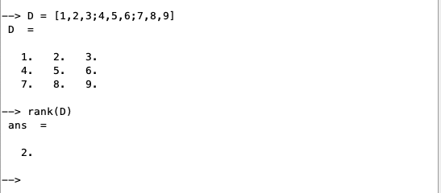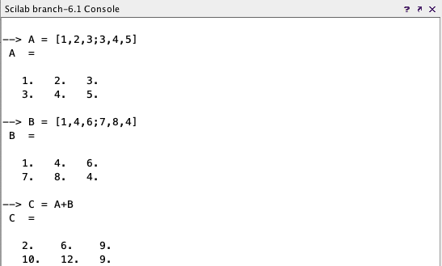

## Functions

To define a new function, we use the function and endfunction Scilab keywords. In the following example, we define the function myfunction, which takes the input argument x, mutiplies it by 2, and returns the value in the output argument y.

*-->function y = myfunction ( x )*

*>y = 2 * x*

* *endfunction*

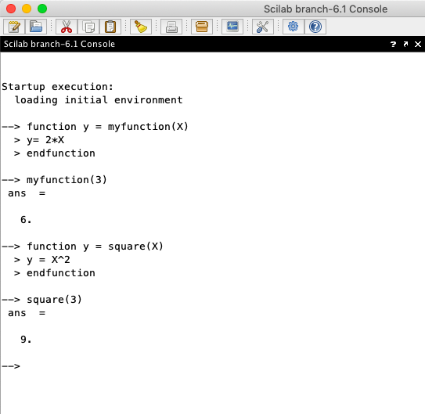

## Plotting:

Producing plots and graphics is a very common task for analysing data and creating reports. Scilab offers many ways to create and customize various types of plots and charts. In this section, we present how to create 2D plots and contour plots. Then we customize the title and the legend of our graphics. We finally export the plots so that we can use it in a report.

Scilab can produce many types of 2D and 3D plots. The following is a short list of several common charts that Scilab can create:

* + x-y plots: plot,
  + contour plots: contour,
  + 3D plots: surf,
  + histograms: histplot,
  + bar charts:

-->function f = myquadratic ( x )

> f = x ^2

* endfunction

-->xdata = linspace ( 1 , 10 , 50 );

-->ydata = myquadratic ( xdata );

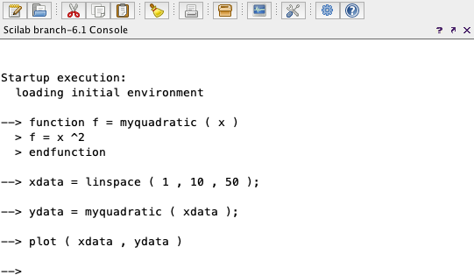-->plot ( xdata , ydata )

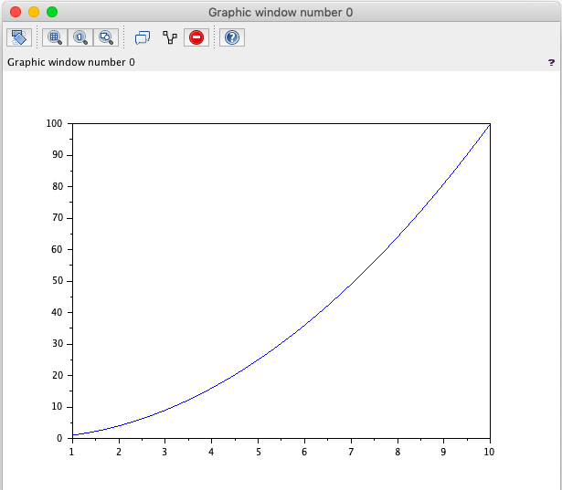

# Experiment – 2

## AIM –

Write a program in Scilab to Calculate Frequency Reuse Distance ,Co- Channel Interference reduction factor, Cellular System Capacity, S/I Ratio for a given variables.

## Code:

r = input("Enter the radius ")

n = input("Enter the number of cells in a cluster ")

d = r*sqrt(3*n)

q = d/r

disp("The frequency reuse distance is ",d)

disp("the frequency reuse ratio is ",q)

z=1/n

disp('frequency reuse factor is',z)

p = input('Enter the total number of channels in the cluster ')

n = input('enter the no. of clusters in the system ')

c = p*n

disp('The total capacity of the system ',c)

x = input('enter path loss component ')

o = input('the total no. of cochannel cell exist in the first tier ')

w = (q^x)/o

disp('the signal to interference ratio is ', w)

## Output:

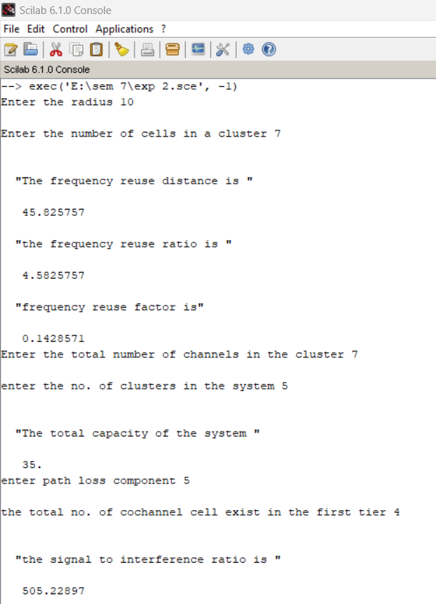

**VIVA VOCE**

**Q1. How can we improve the capacity and coverage area of a cellular system? Ans.** There are 3 techniques for improving cell capacity in cellular system, namely:

* Cell Splitting.
* Sectoring.
* Coverage Zone Approach.

## CELL SPLITTING:

* + It is process of subdividing a congested cell into smaller cells, each with its own base station and a corresponding reduction in antenna height and transmitter power.
  + Cell splitting increases capacity of cellular system since it increases number of times that channels are reused, it preserves frequency reuse plan.
  + It defines new cells which have smaller radius than original cells and by installing these smaller cells called microcells between existing cells, that is radius will be half of the original cell.
  + Thus, capacity increases due to additional number of channels per unit area, but does not disturb the channel allocation scheme required to maintain the minimum co-channel reuse ratio Q between co-channel cells.

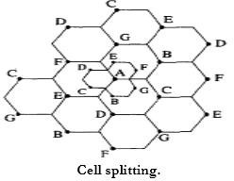

## SECTORING:

* + This is another method to increase cellular capacity and coverage by keeping cell radius unchanged and decreasing D/R ratio.
  + In this approach, capacity improvement is achieved by reducing the number of cells in a cluster and thus increasing the frequency reuse.
  + The co-channel interference in a cellular system may be decreased by replacing a single Omni-directional antenna at the base station by several directional antennas, each radiating within a specified sector.
  + The factor by which the co-channel interference is reduced depends on the amount of sectoring used.

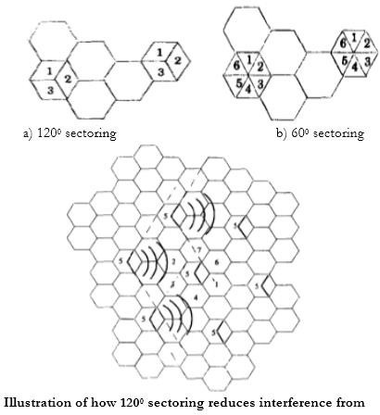

## Advantages:

* + Improvement in Signal capacity.
  + Improvement in signal to interference ratio.
  + Increases frequency reuse.

## Disadvantages:

* + Increase in number of handoffs.
  + Increase in number of antenna at each base station.

## COVERAGE ZONE/ MICROCELL ZONE CONCEPT:

* + This approach was presented by Lee to solve the problem of an increased load on the switching and control link elements of the mobile system due to sectoring.
  + It is based on a microcell concept for 7 cell reuse.
  + In this scheme, each of the three zone sites are connected to a single base station and share the same radio equipment.
  + Multiple zones and a single base station make up a cell. As a mobile travels within the cell, it is served by the zone with the strongest signal.
  + This approach is superior to sectoring since antennas are placed at the outer edges of the cell, and any base station channel may be assigned to any zone by the base station.

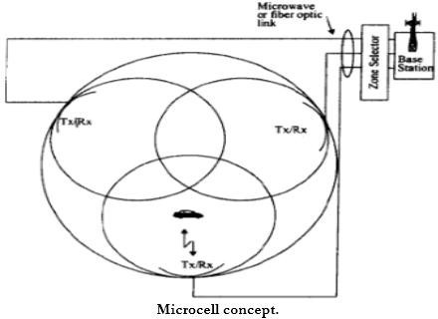

## Q2. Why the shape of cell is not circle?

**Ans.** Circle is the first natural choice to represent the coverage area of a base station. But while adopting this shape, adjacent cells cannot be overlaid upon a map without leaving gaps or creating overlapping regions. Hexagonal cell shape is perfect over square or triangular cell shapes in cellular architecture because it covers an entire area without overlapping i.e. they can cover the entire geographical region without any gaps.

## Q3. How is frequency reuse distance measured in cellular system?

**Ans.** Frequency reusing is the concept of using the same radio frequencies within a given area, that are separated by considerable distance, with minimal interference, to establish communication.

* Frequency reuse offers the following benefits −
* Allows communications within cell on a given frequency
* Limits escaping power to adjacent cells
* Allows re-use of frequencies in nearby cells
* Uses same frequency for multiple conversations
* 10 to 50 frequencies per cell

For example, when **N** cells are using the same number of frequencies and **K** be the total number of frequencies used in systems. Then each **cell frequency** is calculated by using the formulae **K/N**.

In Advanced Mobile Phone Services (AMPS) when K = 395 and N = 7, then frequencies per cell on an average will be 395/7 = 56. Here, **cell frequency** is 56.

## Q4. Which is the standard unit used to show the signal strength in mobile?

**Ans**. Cellular signal strength is measured in decibels (dB), and typically range from -50 dB to -110 dB. The dB scale is logarithmic.

## Q5. Why frequency reuse is required?

**Ans.** Frequency reuse is the process of using the same radio frequencies on radio transmitter sites within a geographic area that are separated by sufficient distance to cause minimal interference with each other. Frequency reuse allows for a dramatic increase in the number of customers that can be served (capacity) within a geographic area on a limited amount of radio spectrum (limited number of radio channels). Frequency reuse allows WiMAX system operators to reuse the same frequency at different cell sites within their system operating area.

# Experiment – 3

## AIM

Write a program in Scilab to Calculate maximum traffic intensity and maximum number of users accommodated in Erlang B and Erlang C system for given no of channels.

## Code:

function **n**=factorial(**n**)

if (**n**<=0) then **n** = 1 else

**n** = **n**\* factorial(**n**-1) end

endfunction

function **p1**=erlangB(**A1**, **c1**)

pr2=0;

pr1=**A1**^**c1**/factorial(**c1**);

for k=1:**c1**

pr2 = pr2+(**A1**^k/factorial(k));

end

**p1**=pr1/pr2;

endfunction

function [**p2**]=erlangC(**A2**, **c2**)

temp_1=0;

for k =0:**c2**-1

temp_1= temp_1+**A2**^k/factorial(k);

end

denominator = A^**c2**+(factorial(**c2**)*(1-(**A2**/c))*temp_1);

**p2**=**A2**^**c2**/denominator;

endfunction

pr_blocking = input("Enter probability of blocking");

pr_delay = input('enter probability of block call delay');

y=input("Enter call rate");

H=input("Enter the average call duration");

c=input("Enter no. of channels");

disp("no of channels");

disp(c);

Au=y*H;

p=0;

for A=1:1:100

while(p<pr_blocking)

[p] = erlangB(A,c);

A=A+1;

end

disp("for blocking probability of",pr_blocking); disp("Maximum traffic intensity",A-1);

u=(A-1)/Au;

disp('no of users are accomodated in erlangB',u);

break;

end

p=0;

for A=1:1:100

while(p<pr_delay)

[p] = erlangC(A,c); A=A+1;

end

disp("for blocking call delay probability of",pr_blocking);

disp("Maximum traffic intensity",A-1);

u=(A-1)/Au;

disp('no of users are accomodated in erlangC',u);

break;

end

## Output:

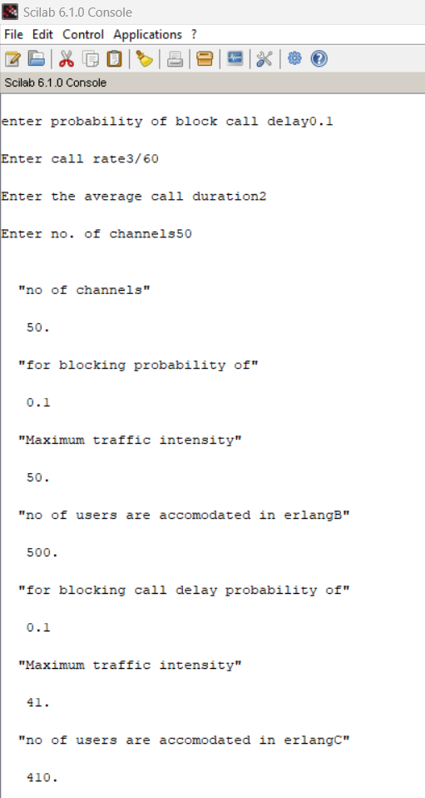

**VIVA VOCE**

## Q1. How is Erlang traffic calculated?

**Ans.** Traffic per user Au = λH, where λ is the request rate and H is holding time. It is calculated in Erlangs.

One Erlang: traffic in channel completely occupied.

0.5 Erlang: channel occupied 30 minutes in an hour.

## Q2. What is Erlang B?

**Ans. Erlang-B** should be used when failure to get a free resource results in the customer being denied service. The customer’s request is rejected as no free resources are available.

**Q3. What is Erlang C?**

**Ans. Erlang-C** should be used when failure to get a free resource results in the customer being added into a queue. The customers stay in the queue until a free resource can be found.

## Q4. What is trunking?

**Ans. Trunking :** A radio system where the channel is allocated on demand by user is called "*trunked*" system. The concept of trunking allows a large number of users to share the relatively small number of channels in a cell by providing access to each user, on demand, from a pool of available channels.

**Q5. What is grade of service?**

**Ans. Grade of Service:** It is a measure of the ability of a user yo access a trunked system during the busiest hour. It is the measure of congestion which is specified as the probability of a call being blocked (for Erlang B) or the probability of call being delayed beyond a certain amount of time (for Erlang C).

# Experiment – 4

## AIM –

Write a Program in Scilab to calculate Bit Error rate performance of BPSK modulated signal over only AWGN channel and AWGN and Rayleigh channel both.

## Code:

clc; n=10000; data_stream=grand(1,n,"uin",0,1); bpsk_stream=2*data_stream-1; snr=1:20; l=length(snr);

s_AWGN=0;

s_AWGN_Ray=0; biterror_AWGN=[]; biterror_AWGN_Rayleigh=[]; for k=1:1:l

h=1/sqrt(2)*(rand(1,n,'normal')+%i*(rand(1,n,'normal'))); noise=1/sqrt(2)*(10^(-

(k/20)))*(rand(1,length(bpsk_stream),'normal')+%i*(rand(1,length(bpsk_stream),'normal'))); s_AWGN=s_AWGN+noise;

s_AWGN_RAY=s_AWGN.*h+noise; received_signal=conj(h).*s_AWGN_RAY; recdata_AWGN=[]; recdata_AWGN_Rayleigh=[]; for i=1:1:n

if (real(s_AWGN(i))>=0) output_AWGN=1;

else

output_AWGN=0; end recdata_AWGN(i) = output_AWGN; end

for i=1:1:n

if (real(s_AWGN_RAY(i))>=0) output_AWGN_Rayleigh=1;

else

output_AWGN_Rayleigh=0; end recdata_AWGN_Rayleigh(i) = output_AWGN_Rayleigh; end

err_AWGN = 0; err_AWGN_Rayleigh = 0; for i=1:1:n

if recdata_AWGN[i] ~= bpsk_stream(i) err_AWGN = err_AWGN + 1;

end

end

for i=1:1:n

if recdata_AWGN_Rayleigh(i) ~= bpsk_stream(i) err_AWGN_Rayleigh = err_AWGN_Rayleigh + 1;

end end

biterror_AWGN(k) = err_AWGN/n; biterror_AWGN_Rayleigh(k) = err_AWGN_Rayleigh/n;

end subplot(2,1,1); plot(snr,biterror_AWGN); xgrid() subplot(2,1,2); plot(snr,biterror_AWGN_Rayleigh); xgrid()

## Output:

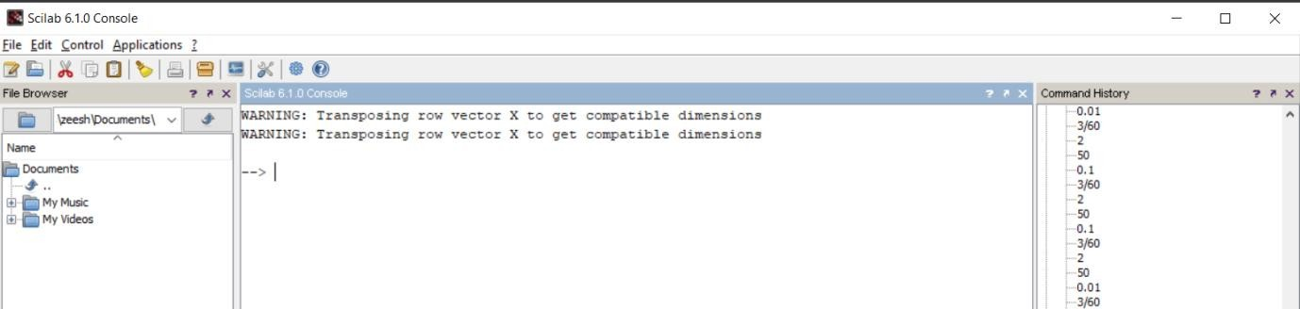

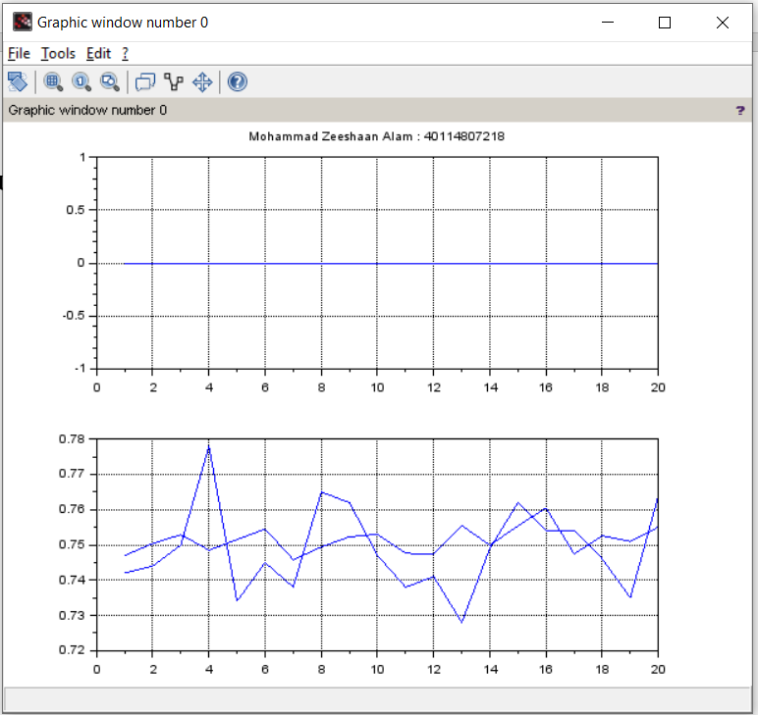

**AIM –**

# Experiment – 5

Program in Scilab to Generate Walsh Codes and then spread the user information using it.

Program Code

clc;

w = [0 0;0 1];

disp('original walsh code matrix = ',w); function [**w_inv**]=compliment(**w**)

for i=1:1:length(**w**(1,:))

for j=1:1:length(**w**(1,:)) if

**w**(i,j)== 0 **w_inv**(i,j)=1; else **w_inv**(i,j)=0; end

end end endfunction

comp = compliment(w); disp('compliment of walsh code',comp); w = [w w; w comp]; disp("New Matrix",w);

len=length(w(2,:));

disp("Length of new matrix :",len); zeeshaan_input1 = [1 0 0 1 0];

zeeshaan_input2 = [0 1 1 1 0];

zeeshaan_input3 = [1 0 1 1 0]; disp("input1",input1); disp("input2",input2); disp("input3",input3); Wcode1 = w(2,:);

Wcode2 = w(3,:);

Wcode3 = w(4,:);

spread = [] spread1 = [] spread2 = [] spread3 = []

for i=1:1:length(input1)

for j=1:1:length(Wcode1)

variable_xor1 = bitxor(input1(1,i),Wcode1(1,j)); spread1 = [spread1 variable_xor1];

end end

disp("Code1 Spread",spread1); for i=1:1:length(input2)

for j=1:1:length(Wcode2)

variable_xor2 = bitxor(input2(1,i),Wcode2(1,j)); spread2 = [spread2 variable_xor2];

end

end

disp("Code2 Spread",spread2); for i=1:1:length(input3)

for j=1:1:length(Wcode3)

variable_xor3 = bitxor(input3(1,i),Wcode3(1,j)); spread3 = [spread3 variable_xor3];

end end

disp("Code3 Spread",spread3); spread = [spread1;spread2;spread3]; disp("Final Spread Code”,spread);

**Output:**

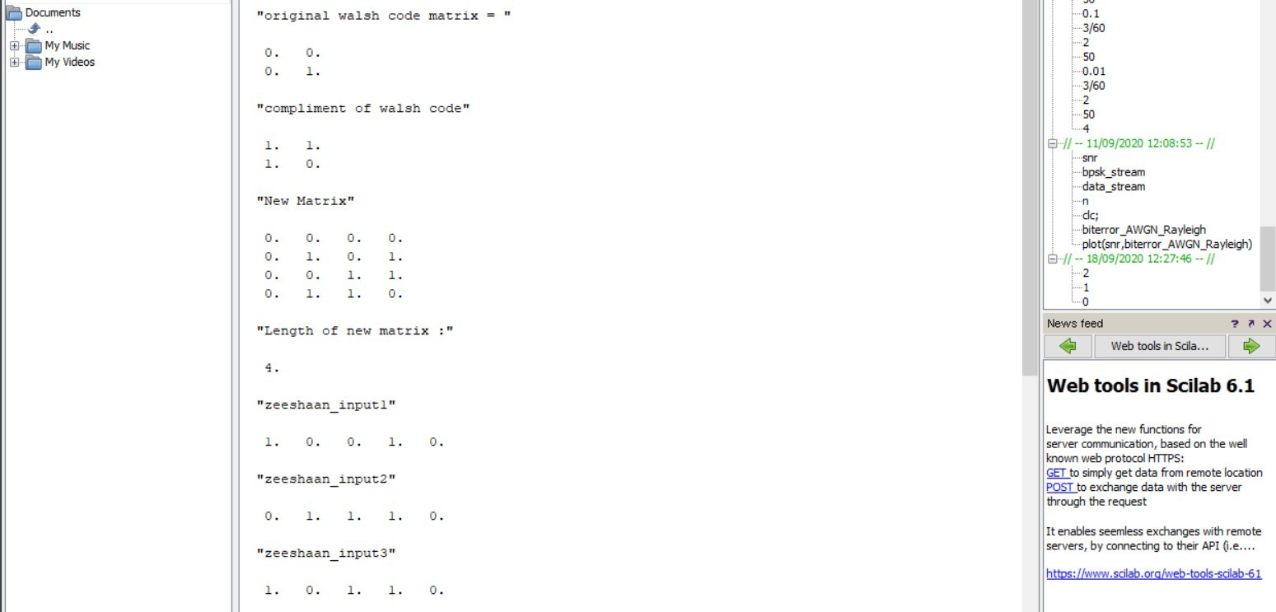

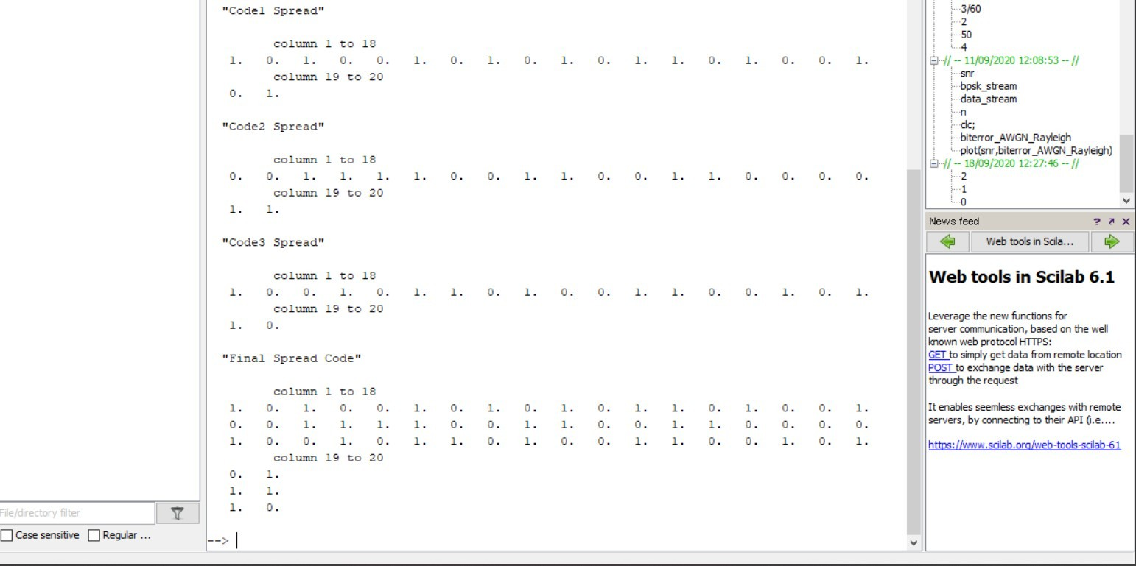

# Experiment – 6

## AIM –

Write a program in scilab to Generate PN Sequence for CDMA Systems.

## Code:

clc; r(1)= 1;

r(2)= 0;

r(3)= 1;

r(4)= 0;

R = [r(1) r(2) r(3) r(4)]; PN = [];

len = length(r); disp('lemgth of input',len);

disp('initial bit pattern of flip flops',R); for i=1:1:((2^len)-1)

temp1 = r(1); temp2 = r(2); temp3 = r(3); temp4 = r(4); PN = [PN r(4)];

temp1 = bitxor(temp3,temp4); r(4) = r(3);

r(3) = r(2);

r(2) = r(1);

r(1) = temp1;

R = [r(1) r(2) r(3) r(4)];

disp('current bit pattern of flip flops',R);

end

disp('15 bit pattern',PN); for i=1:1:((2^len)-1)

if(PN(i)==0)

PN(i) = -1;

end

end

disp('After replacing 0 with -1 the 15 bit pattern',PN);

info = [1 -1 -1 1];

leninfo = length(info);

disp("length of data ",length(info));

spread = [];

for i=1:1:leninfo

for j=1:1:length(PN)

x = info(1,i)*PN(1,j); spread = [spread x];

end

end

disp("spread ",spread); len_spread = length(spread);

disp("length of spreaded data", len_spread); PN = [PN PN PN PN];

disp("Updated PN : ",PN); despread = [];

for i=1:1:length(spread)

x = spread(1,i)*PN(1,i); despread = [despread x];

end

disp("multiplied output",despread);

sum_col = [sum(despread(1:15)) sum(despread(16:30)) sum(despread(31:45)) sum(despread(46:60))]; disp("sum total",sum_col);

received_signal = [];

for i=1:1:length(sum_col)

received_signal =[received_signal sum_col(i)/15];

end

disp("received signal”,received_signal);

**Output:**

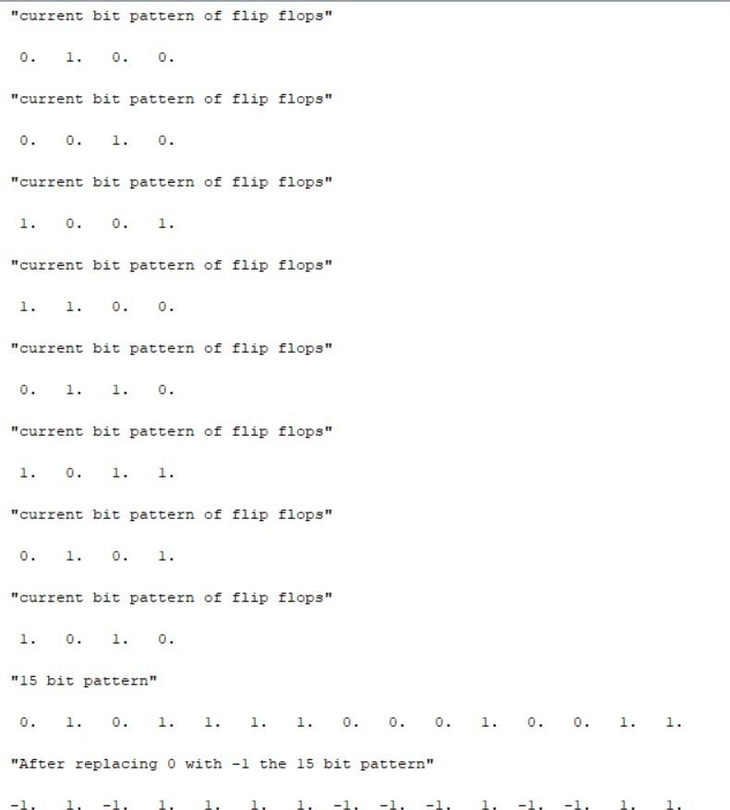

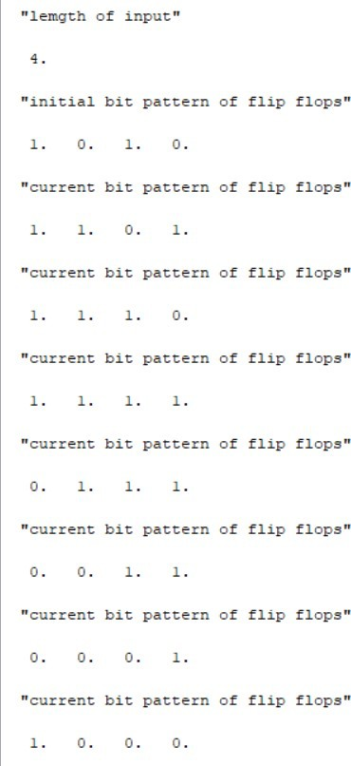



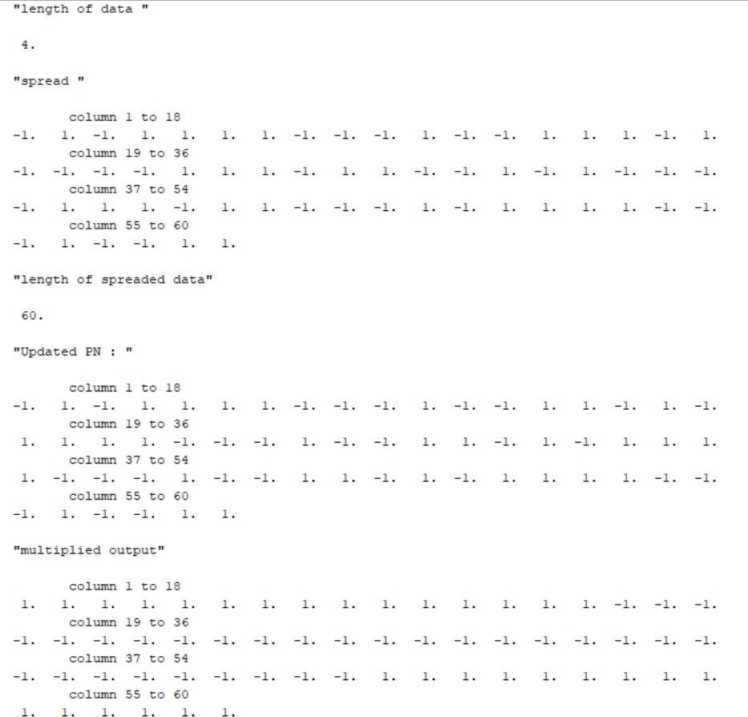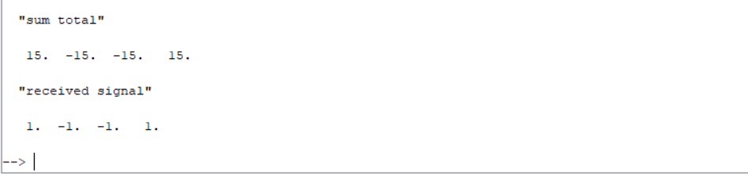

# Experiment – 7

## AIM –

Write a Program in NS3 to connect WIFI TO BUS (CSMA) Network.

## Code:

#include "ns3/core-module.h"

#include "ns3/point-to-point-module.h" #include "ns3/network-module.h" #include "ns3/applications-module.h" #include "ns3/wifi-module.h"

#include "ns3/mobility-module.h" #include "ns3/csma-module.h" #include "ns3/internet-module.h"

using namespace ns3;

NS_LOG_COMPONENT_DEFINE ("ThirdScriptExample"); int main (int argc, char *argv[])

{

bool verbose = true; uint32_t nCsma = 3; uint32_t nWifi = 3; bool tracing = false;

CommandLine cmd;

cmd.AddValue ("nCsma", "Number of \"extra\" CSMA nodes/devices", nCsma); cmd.AddValue ("nWifi", "Number of wifi STA devices", nWifi); cmd.AddValue ("verbose", "Tell echo applications to log if true", verbose); cmd.AddValue ("tracing", "Enable pcap tracing", tracing);

cmd.Parse (argc,argv);

//Check for valid number of csma or wifi nodes

//250 should be enough, otherwise IP addresses

//soon become an issue

if (nWifi > 250 || nCsma > 250)

{

std::cout << "Too many wifi or csma nodes, no more than 250 each." << std::endl; return 1;

}

if (verbose)

{

LogComponentEnable ("UdpEchoClientApplication", LOG_LEVEL_INFO); LogComponentEnable ("UdpEchoServerApplication", LOG_LEVEL_INFO);

}

NodeContainer p2pNodes; p2pNodes.Create (2);

PointToPointHelper pointToPoint;

pointToPoint.SetDeviceAttribute ("DataRate", StringValue ("5Mbps")); pointToPoint.SetChannelAttribute ("Delay", StringValue ("2ms"));

NetDeviceContainer p2pDevices;

p2pDevices = pointToPoint.Install (p2pNodes);

NodeContainer csmaNodes; csmaNodes.Add (p2pNodes.Get (1)); csmaNodes.Create (nCsma);

CsmaHelper csma;

csma.SetChannelAttribute ("DataRate", StringValue ("100Mbps")); csma.SetChannelAttribute ("Delay", TimeValue (NanoSeconds (6560)));

NetDeviceContainer csmaDevices; csmaDevices = csma.Install (csmaNodes);

NodeContainer wifiStaNodes; wifiStaNodes.Create (nWifi);

NodeContainer wifiApNode = p2pNodes.Get (0);

YansWifiChannelHelper channel = YansWifiChannelHelper::Default (); YansWifiPhyHelper phy = YansWifiPhyHelper::Default (); phy.SetChannel (channel.Create ());

WifiHelper wifi;

wifi.SetRemoteStationManager ("ns3::AarfWifiManager"); WifiMacHelper mac;

Ssid ssid = Ssid ("ns-3-ssid"); mac.SetType ("ns3::StaWifiMac", "Ssid", SsidValue (ssid), "ActiveProbing", BooleanValue (false));

NetDeviceContainer staDevices;

staDevices = wifi.Install (phy, mac, wifiStaNodes); mac.SetType ("ns3::ApWifiMac", "Ssid", SsidValue (ssid)); NetDeviceContainer apDevices;

apDevices = wifi.Install (phy, mac, wifiApNode); MobilityHelper mobility;

mobility.SetPositionAllocator ("ns3::GridPositionAllocator", "MinX", DoubleValue (0.0), "MinY", DoubleValue (0.0),

"DeltaX", DoubleValue (5.0),

"DeltaY", DoubleValue (10.0),

"GridWidth", UintegerValue (3), "LayoutType", StringValue ("RowFirst"));

mobility.SetMobilityModel ("ns3::RandomWalk2dMobilityModel", "Bounds", RectangleValue (Rectangle (-50, 50, -50, 50)));

mobility.Install (wifiStaNodes);

mobility.SetMobilityModel ("ns3::ConstantPositionMobilityModel"); mobility.Install (wifiApNode);

InternetStackHelper stack; stack.Install (csmaNodes); stack.Install (wifiApNode);

stack.Install (wifiStaNodes); Ipv4AddressHelper address;

address.SetBase ("10.1.1.0", "255.255.255.0");

Ipv4InterfaceContainer p2pInterfaces; p2pInterfaces = address.Assign (p2pDevices);

address.SetBase ("10.1.2.0", "255.255.255.0");

Ipv4InterfaceContainer csmaInterfaces; csmaInterfaces = address.Assign (csmaDevices);

address.SetBase ("10.1.3.0", "255.255.255.0");

address.Assign (staDevices); address.Assign (apDevices);

UdpEchoServerHelper echoServer (9);

ApplicationContainer serverApps = echoServer.Install (csmaNodes.Get (nCsma)); serverApps.Start (Seconds (1.0));

serverApps.Stop (Seconds (10.0));

UdpEchoClientHelper echoClient (csmaInterfaces.GetAddress (nCsma), 9); echoClient.SetAttribute ("MaxPackets", UintegerValue (1)); echoClient.SetAttribute ("Interval", TimeValue (Seconds (1.0))); echoClient.SetAttribute ("PacketSize", UintegerValue (1024));

ApplicationContainer clientApps = echoClient.Install (wifiStaNodes.Get (nWifi - 1)); clientApps.Start (Seconds (2.0));

clientApps.Stop (Seconds (10.0)); Ipv4GlobalRoutingHelper::PopulateRoutingTables (); Simulator::Stop (Seconds (10.0));

if (tracing == true)

{

pointToPoint.EnablePcapAll ("third"); phy.EnablePcap ("third", apDevices.Get (0)); csma.EnablePcap ("third", csmaDevices.Get (0), true);

}

Simulator::Run (); Simulator::Destroy (); return 0;

}

**Output:**

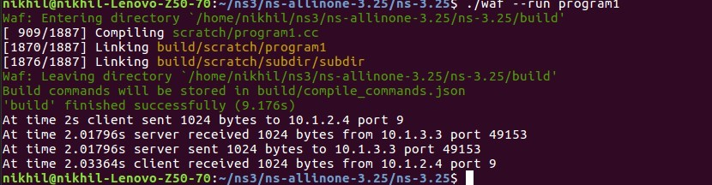

# Experiment – 8

## AIM –

Write a Program in NS3 to create WIFI Network in SIMPLE INFRASTRUCTURE MODE (of nodes).

## Code:

#include "ns3/core-module.h" #include "ns3/network-module.h" #include "ns3/mobility-module.h" #include "ns3/config-store-module.h" #include "ns3/wifi-module.h" #include "ns3/internet-module.h" #include

<iostream> #include <fstream> #include <vector> #include <string>

using namespace ns3; NS_LOG_COMPONENT_DEFINE ("WifiSimpleInfra"); void ReceivePacket (Ptr<Socket> socket)

{

while (socket->Recv ())

{

NS_LOG_UNCOND ("Received one packet!");

}

}

static void GenerateTraffic (Ptr<Socket> socket, uint32_t pktSize, uint32_t pktCount, Time pktInterval )

{

if (pktCount > 0)

{

socket->Send (Create<Packet> (pktSize)); Simulator::Schedule (pktInterval, &GenerateTraffic, socket, pktSize,pktCount-1, pktInterval);

}

else

{

socket->Close ();

}

}

int main (int argc, char *argv[])

{

std::string phyMode ("DsssRate1Mbps"); double rss = -80; // -dBm

uint32_t packetSize = 1000; // bytes uint32_t numPackets = 1;

double interval = 1.0; // seconds bool verbose = false;

CommandLine cmd;

cmd.AddValue ("phyMode", "Wifi Phy mode",phyMode); cmd.AddValue ("rss", "received signal strength", rss);

cmd.AddValue ("packetSize", "size of application packet sent", packetSize); cmd.AddValue ("numPackets", "number of packets generated", numPackets); cmd.AddValue ("interval", "interval (seconds) between packets", interval); cmd.AddValue ("verbose", "turn on all WifiNetDevice log components", verbose);

cmd.Parse (argc, argv); // Convert to time object Time interPacketInterval = Seconds (interval);

// disable fragmentation for frames below 2200 bytes

Config::SetDefault ("ns3::WifiRemoteStationManager::FragmentationThreshold", StringValue ("2200"));

// turn off RTS/CTS for frames below 2200 bytes

Config::SetDefault ("ns3::WifiRemoteStationManager::RtsCtsThreshold", StringValue ("2200"));

// Fix non-unicast data rate to be the same as that of unicast Config::SetDefault ("ns3::WifiRemoteStationManager::NonUnicastMode", StringValue (phyMode));

NodeContainer c; c.Create (2);

// The below set of helpers will help us to put together the wifi NICs we want WifiHelper wifi;

if (verbose)

{

wifi.EnableLogComponents (); // Turn on all Wifi logging

}

wifi.SetStandard (WIFI_PHY_STANDARD_80211b);

YansWifiPhyHelper wifiPhy = YansWifiPhyHelper::Default (); wifiPhy.Set("RxGain",DoubleValue(0)); wifiPhy.SetPcapDataLinkType(YansWifiPhyHelper::DLT_IEEE802_11_RADIO);

YansWifiChannelHelper wifiChannel;

wifiChannel.SetPropagationDelay ("ns3::ConstantSpeedPropagationDelayModel"); wifiChannel.AddPropagationLoss ("ns3::FixedRssLossModel","Rss",DoubleValue (rss)); wifiPhy.SetChannel (wifiChannel.Create ());

WifiMacHelper wifiMac;

wifi.SetRemoteStationManager ("ns3::ConstantRateWifiManager", "DataMode",StringValue (phyMode), "ControlMode",StringValue (phyMode));

Ssid ssid = Ssid ("wifi-default"); // setup sta.

wifiMac.SetType ("ns3::StaWifiMac", "Ssid", SsidValue (ssid), "ActiveProbing", BooleanValue (false));

NetDeviceContainer staDevice = wifi.Install (wifiPhy, wifiMac, c.Get (0)); NetDeviceContainer devices = staDevice;

// setup ap.

wifiMac.SetType ("ns3::ApWifiMac", "Ssid", SsidValue (ssid)); NetDeviceContainer apDevice = wifi.Install (wifiPhy, wifiMac, c.Get (1)); devices.Add (apDevice);

//Note that with FixedRssLossModel, the positions below are not

//used for received signal strength. MobilityHelper mobility;

Ptr<ListPositionAllocator> positionAlloc = CreateObject<ListPositionAllocator> (); positionAlloc->Add (Vector (0.0, 0.0, 0.0));

positionAlloc->Add (Vector (5.0, 0.0, 0.0)); mobility.SetPositionAllocator (positionAlloc); mobility.SetMobilityModel ("ns3::ConstantPositionMobilityModel");

mobility.Install (c);

InternetStackHelper internet; internet.Install (c);

Ipv4AddressHelper ipv4;

NS_LOG_INFO ("Assign IP Addresses."); ipv4.SetBase ("10.1.1.0", "255.255.255.0");

Ipv4InterfaceContainer i = ipv4.Assign (devices);

TypeId tid = TypeId::LookupByName ("ns3::UdpSocketFactory"); Ptr<Socket> recvSink = Socket::CreateSocket (c.Get (0), tid); InetSocketAddress local = InetSocketAddress (Ipv4Address::GetAny (), 80); recvSink->Bind (local); recvSink->SetRecvCallback (MakeCallback (&ReceivePacket));

Ptr<Socket> source = Socket::CreateSocket (c.Get (1), tid);

InetSocketAddress remote = InetSocketAddress (Ipv4Address ("255.255.255.255"), 80); source->SetAllowBroadcast (true);

source->Connect (remote);

// Tracing

wifiPhy.EnablePcap ("wifi-simple-infra", devices);

// Output what we are doing

NS_LOG_UNCOND ("Testing " << numPackets << " packets sent with receiver rss " << rss ); Simulator::ScheduleWithContext (source->GetNode ()->GetId (),

Seconds (1.0), &GenerateTraffic,

source, packetSize, numPackets, interPacketInterval); Simulator::Stop (Seconds (30.0));

Simulator::Run (); Simulator::Destroy (); return 0;

}

## Output:

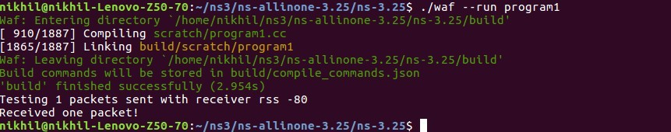

**AIM –**

# Experiment – 9

Write a Program in NS3 to Create a wireless mobile ad-hoc network between three nodes.

## Code:

#include "ns3/core-module.h" #include "ns3/network-module.h" #include "ns3/mobility-module.h" #include "ns3/config-store-module.h" #include "ns3/wifi-module.h" #include "ns3/internet-module.h" #include

<iostream> #include <fstream> #include <vector>

#include <string> using namespace ns3;

NS_LOG_COMPONENT_DEFINE ("WifiSimpleAdhoc"); void ReceivePacket (Ptr<Socket> socket) {

while (socket->Recv ()) {

NS_LOG_UNCOND ("Received one packet!");

}

}

static void GenerateTraffic (Ptr<Socket> socket, uint32_t pktSize, uint32_t pktCount, Time pktInterval) { if (pktCount > 0) {

socket->Send (Create<Packet> (pktSize)); Simulator::Schedule (pktInterval, &GenerateTraffic,

socket, pktSize,pktCount-1, pktInterval);

}

else

}

socket->Close ();

int main (int argc, char *argv[])

{

std::string phyMode ("DsssRate1Mbps"); double rss = -80; // -dBm

uint32_t packetSize = 1000; // bytes uint32_t numPackets = 1;

double interval = 1.0; // seconds bool verbose = false; CommandLine cmd;

cmd.AddValue ("phyMode", "Wifi Phy mode", phyMode); cmd.AddValue ("rss", "received signal strength", rss);

cmd.AddValue ("packetSize", "size of application packet sent", packetSize); cmd.AddValue ("numPackets", "number of packets generated", numPackets); cmd.AddValue ("interval", "interval (seconds) between packets", interval); cmd.AddValue ("verbose", "turn on all WifiNetDevice log components", verbose); cmd.Parse (argc, argv); // Convert to time object Time interPacketInterval = Seconds (interval);

// disable fragmentation for frames below 2200 bytes

Config::SetDefault ("ns3::WifiRemoteStationManager::FragmentationThreshold", StringValue ("2200"));

// turn off RTS/CTS for frames below 2200 bytes

Config::SetDefault ("ns3::WifiRemoteStationManager::RtsCtsThreshold", StringValue ("2200"));

// Fix non-unicast data rate to be the same as that of unicast Config::SetDefault ("ns3::WifiRemoteStationManager::NonUnicastMode", StringValue (phyMode));

NodeContainer c; c.Create (2);

// The below set of helpers will help us to put together the wifi NICs we want WifiHelper wifi;

if (verbose)

wifi.EnableLogComponents (); // Turn on all Wifi logging wifi.SetStandard (WIFI_PHY_STANDARD_80211b);

YansWifiPhyHelper wifiPhy = YansWifiPhyHelper::Default ();

// This is one parameter that matters when using FixedRssLossModel

//set it to zero; otherwise, gain will be added wifiPhy.Set ("RxGain", DoubleValue (0) );

//ns-3 supports RadioTap and Prism tracing extensions for 802.11b wifiPhy.SetPcapDataLinkType (YansWifiPhyHelper::DLT_IEEE802_11_RADIO); YansWifiChannelHelper wifiChannel;

wifiChannel.SetPropagationDelay ("ns3::ConstantSpeedPropagationDelayModel");

//The below FixedRssLossModel will cause the rss to be fixed regardless

//of the distance between the two stations, and the transmit power wifiChannel.AddPropagationLoss ("ns3::FixedRssLossModel","Rss",DoubleValue (rss)); wifiPhy.SetChannel (wifiChannel.Create ());

//Add a mac and disable rate control WifiMacHelper wifiMac;

wifi.SetRemoteStationManager ("ns3::ConstantRateWifiManager", "DataMode",StringValue (phyMode), "ControlMode",StringValue (phyMode));

// Set it to adhoc mode

wifiMac.SetType ("ns3::AdhocWifiMac");

NetDeviceContainer devices = wifi.Install (wifiPhy, wifiMac, c);

//Note that with FixedRssLossModel, the positions below are not

//used for received signal strength. MobilityHelper mobility;

Ptr<ListPositionAllocator> positionAlloc = CreateObject<ListPositionAllocator> (); positionAlloc->Add (Vector (0.0, 0.0, 0.0));

positionAlloc->Add (Vector (5.0, 0.0, 0.0)); mobility.SetPositionAllocator (positionAlloc); mobility.SetMobilityModel ("ns3::ConstantPositionMobilityModel");

mobility.Install (c); InternetStackHelper internet; internet.Install (c); Ipv4AddressHelper ipv4;

NS_LOG_INFO ("Assign IP Addresses."); ipv4.SetBase ("10.1.1.0", "255.255.255.0");

Ipv4InterfaceContainer i = ipv4.Assign (devices);

TypeId tid = TypeId::LookupByName ("ns3::UdpSocketFactory"); Ptr<Socket> recvSink = Socket::CreateSocket (c.Get (0), tid); InetSocketAddress local = InetSocketAddress (Ipv4Address::GetAny (), 80);

recvSink->Bind (local);

recvSink->SetRecvCallback (MakeCallback (&ReceivePacket)); Ptr<Socket> source = Socket::CreateSocket (c.Get (1), tid);

InetSocketAddress remote = InetSocketAddress (Ipv4Address ("255.255.255.255"), 80); source->SetAllowBroadcast (true);

source->Connect (remote);

// Tracing

wifiPhy.EnablePcap ("wifi-simple-adhoc", devices);

// Output what we are doing

NS_LOG_UNCOND ("Testing " << numPackets << " packets sent with receiver rss " << rss ); Simulator::ScheduleWithContext (source->GetNode ()->GetId (), Seconds (1.0), &GenerateTraffic, source, packetSize, numPackets, interPacketInterval);

Simulator::Run (); Simulator::Destroy (); return 0;

}

## Output:

